Name : Abdul Rehman Section :B

Course : CCN Roll No : CT-22052

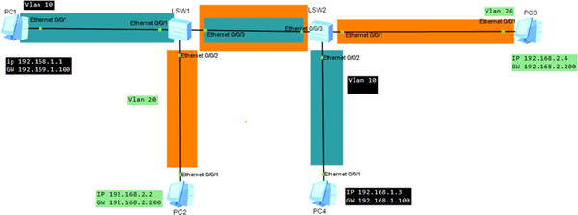

**PC1 configuration:**

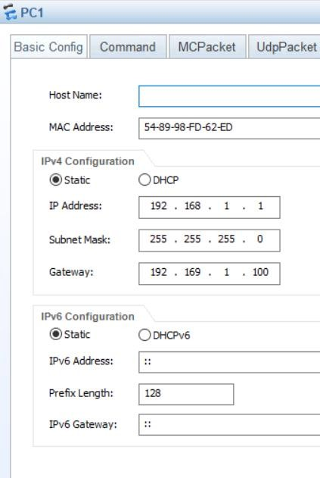

**PC2 configuration:**

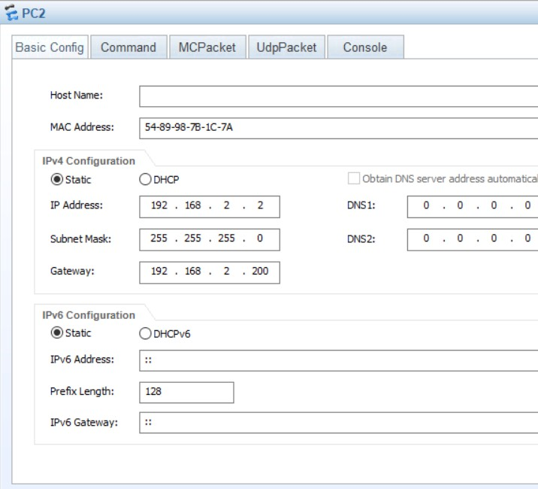

**PC3 configuration:**

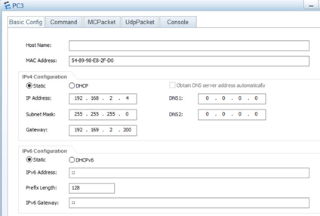

**PC4 configuration:**

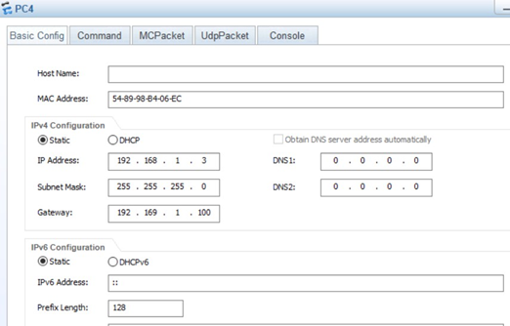

# SWITCH 1 Commands:

system-view vlan batch 10 20

interface GigabitEthernet 0/0/1 port link-type access

port default vlan 10 quit

interface GigabitEthernet 0/0/2 port link-type access

port default vlan 20 quit

interface GigabitEthernet 0/0/3 port link-type trunk

port trunk allow-pass vlan 10 20 quit

interface Vlanif 10

ip address 192.168.1.100 24 quit

interface Vlanif 20

ip address 192.168.2.200 24 quit

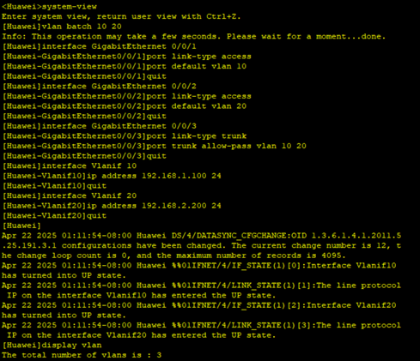

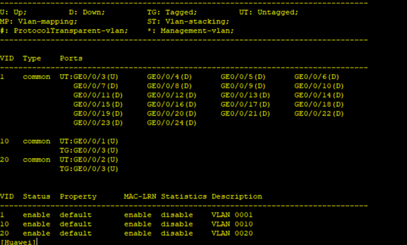

# SWITCH 2 Commands:

system-view vlan batch 10 20

interface GigabitEthernet 0/0/1 port link-type access

port default vlan 20 quit

interface GigabitEthernet 0/0/2 port link-type access

port default vlan 10 quit

interface GigabitEthernet 0/0/3 port link-type trunk

port trunk allow-pass vlan 10 20 quit

interface Vlanif 10

ip address 192.168.1.100 24 quit

interface Vlanif 20

ip address 192.168.2.200 24 quit

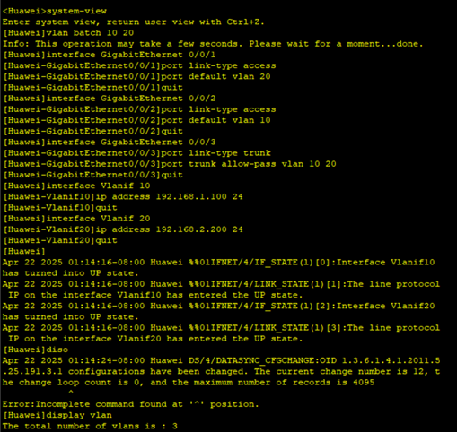  
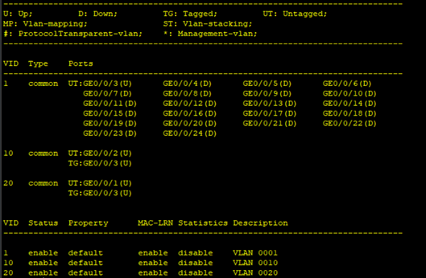

**OUTPUT:**

**Pinged PC4 from PC1:**

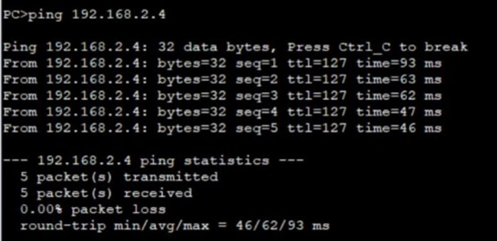

**PC4 from PC1:**